1.What are the two values of the Boolean data type? How do you write them?

- true =1

-False = 0

2. What are the three different types of Boolean operators?

-And , Or & Not

3. Make a list of each Boolean operator's truth tables (i.e. every possible combination of Boolean values for the operator and what it evaluate ).

Please ignore xor table

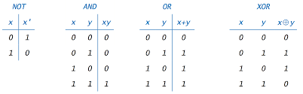

4. What are the values of the following expressions?

(5 > 4) and (3 == 5) - False

not (5 > 4) - False

(5 > 4) or (3 == 5) - True

not ((5 > 4) or (3 == 5)) - False

(True and True) and (True == False)- False

(not False) or (not True) – True

5. What are the six comparison operators?

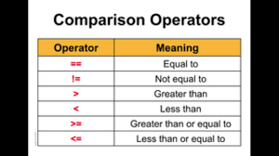

6. How do you tell the difference between the equal to and assignment operators?Describe a condition and when you would use one.

= - this is assignment operator’s which use to assign value to variable

== - this is equality operator which use to check equality of two variables

7. Identify the three blocks in this code:

spam = 0

if spam == 10:

print('eggs')

if spam > 5:

print('bacon')

else:

print('ham')

print('spam')

print('spam')

spam = 0

**if spam == 10:**

print('eggs')

**if spam > 5:**

print('bacon')

**else:**

print('ham')

print('spam')

print('spam')

8. Write code that prints Hello if 1 is stored in spam, prints Howdy if 2 is stored in spam, and prints Greetings! if anything else is stored in spam.

spam = 757

if spam == 1:

print('hello')

else:

if spam == 2:

print('Howdey')

else:s

print('greetings')

9.If your programme is stuck in an endless loop, what keys you’ll press?

- press ctrl + c

10. How can you tell the difference between break and continue?

| **Sr. No.** | **Key** | **Break** | **Continue** |
| --- | --- | --- | --- |
| 1 | Functionality | Break statement mainly used to terminate the enclosing loop such as while, do-while, for or switch statement wherever break is declared. | Continue statement mainly skip the rest of loop wherever continue is declared and execute the next iteration. |
| 2 | Executional flow | Break statement resumes the control of the program to the end of loop and made executional flow outside that loop. | Continue statement resumes the control of the program to the next iteration of that loop enclosing 'continue' and made executional flow inside the loop again. |
| 3 | Usage | As mentioned break is used for the termination of enclosing loop. | On other hand continue causes early execution of the next iteration of the enclosing loop. |

11. In a for loop, what is the difference between range(10), range(0, 10), and range(0, 10, 1)?

-Range(10 ) will generate numbers from 0 to 9

- range(0, 10) will generate numbers from 0 to 9

- range(0, 10, 1) will generate numbers from 0 to 9 by step of 1

12. Write a short program that prints the numbers 1 to 10 using a for loop. Then write an equivalent program that prints the numbers 1 to 10 using a while loop.

for x in range(1,11):

print(x)

x=1

while x in range(1,11):

print(x)

x = x+1

13. If you had a function named bacon() inside a module named spam, how would you call it after importing spam?

-Spam.bacon()